Tech Thursday

Boundaries

United States

Use Wikipedia – Territorial_evolution_of_the_United_States as a starting point

- How were borders of the states and territories determined in the 18th century

Find for all the borders on
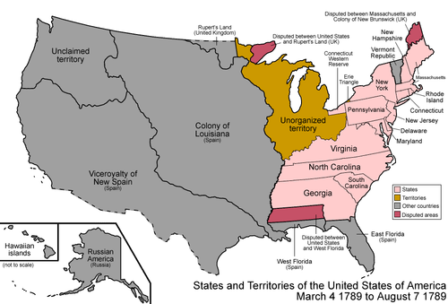

- What has created the modern borders for South American nations today?

